Creating main line CI pipeline
Create a new Folder item with name “Central_CI” using “New Item” option as shown
below. Add jobs of type Freestyle Project for each of tasks needed in the the
continuous integration pipeline
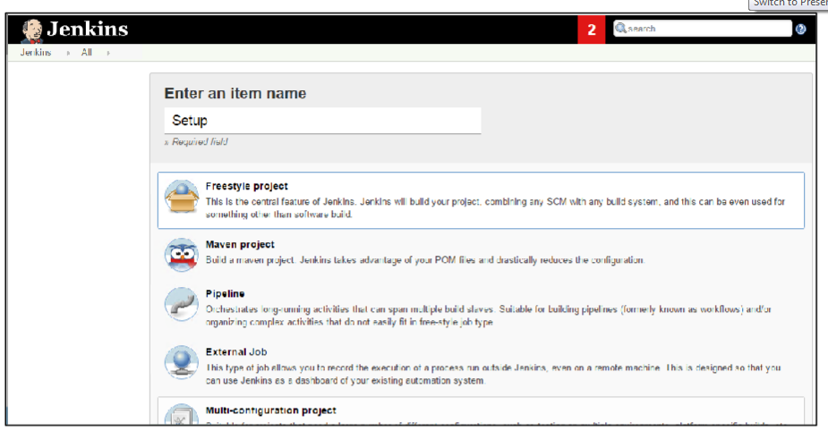
Step 1: Create below mentioned job - Setup
